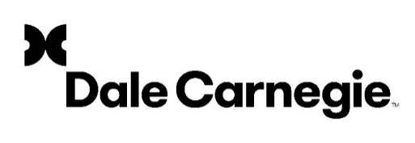
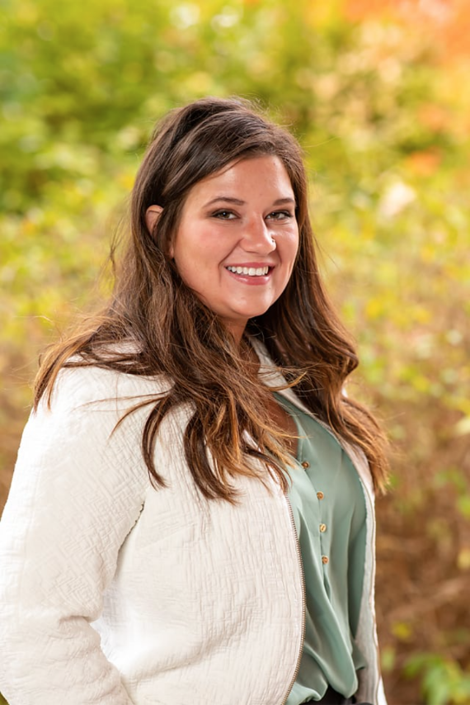
Work Experience
- Visiting Leadership Speaker for THE School of Hospitality Business, Michigan State University
- Holland Young Professionals Philanthropy Committee Chair
- Co-Creator and Facilitator of My L.I.F.E. Youth Dale Carnegie program for 500+ middle & high school students
- Designed lead generation and market research process for new and dormant clients across entire franchise
- Serves 100+ West Michigan businesses

Featured Skills
- Program Management • Sales
- Customer Service • Client Engagement

Dale Carnegie Trainer Certifications
- The Dale Carnegie Course
- Digital Producer Certification
- Digital Trainer Certification

Education and Certifications
- BA in Communication
- Dale Carnegie Trainer Certified: Dale Carnegie Course in Effective Communication and Human Relations
- Dale Carnegie Programs Completed: Dale Carnegie Course in Effective Communication and Human Relations, High Impact Presentations, Winning with Relationship Selling, Develop Your Leadership Potential, Leadership Training for Managers
- WebEx, Live-Online Digital Producer
- WebEx, Live-Online Digital Trainer
- Certified Dale Carnegie Sales Professional

References
Phil Zeller, CEO, Ralph Nichols Group, Inc.
2450 44th SE St.303A, Grand Rapids, MI 49512
517-525-0569, Phil.Zeller@DaleCarnegie.com

Alyssa Bellinger
Performance Consultant
Trainer / Live-Online Digital Producer / Live-Online Digital Trainer

2450 44th St SE Ste. 303A
Grand Rapids, MI 49512
Phone (989-600-5425)
Alyssa.bellinger@dalecarnegie.com
linkedin.com/in/alyssa-bellinger-23881645

Language Fluency
English

Available to Travel
Yes/Worldwide

Notable
Generates opportunities for West Michigan organizations to engage employees.
Produces and Facilitates Live-Online classes for local Dale Carnegie Training offered by Ralph Nichols Group

Coordinates customized solutions for West Michigan Companies to increase results and return on investment.

